EXPERIMENT 2:TABLE CREATION AND VALUE INSERTION

1) CREATE TABLE Inst(Instructor_ID int primary key,Name varchar(30) not null,Department varchar(30));
DESCRIBE Inst;
2) CREATE TABLE COURSE_63(COURSE_ID int primary key,TITLE varchar(30) not null,CREDITS int check(CREDITS>0),Instructor_ID int, foreign key(Instructor_ID )references Inst(Instructor_ID));
DESCRIBE COURSE_63;
3) CREATE TABLE STUDENT_63(ROLL_NO int primary key,NAME varchar(30),DOB DATE,DEPARTMENT VARCHAR(30));
DESC STUDENT_63;
4) CREATE TABLE ENROLLMENT(ROLL_NO int,COURSE_ID int, GRADE char(2), primary key (ROLL_NO,COURSE_ID),FOREIGN KEY(ROLL_NO)references STUDENT_63(ROLL_NO) ON DELETE CASCADE,
FOREIGN KEY (COURSE_ID) references COURSE_63(COURSE_ID) ON DELETE CASCADE);
DESC ENROLLMENT;

1)
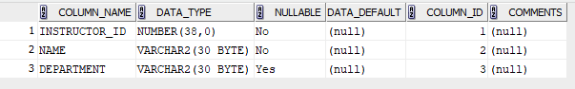

2)
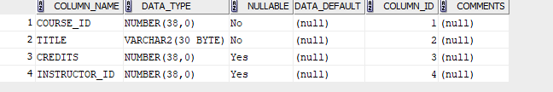

3)

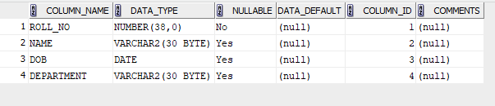

4)
